**Interview questions**

1)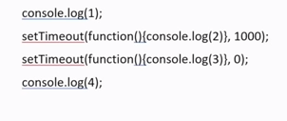What is output in above program?What is role of setTimeout function?

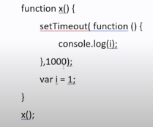

2)What will be the output in above program?

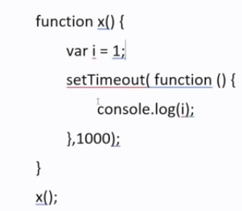

3) What will be the output in above program?

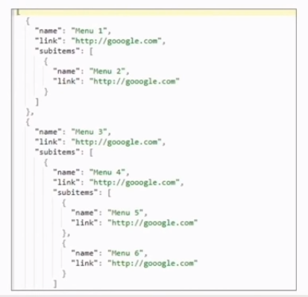

4)In above tree structure of object,what will be the approach if Iwant to go in this node and want to display name in every node?

5)What is life cycle methods in React?what is use of this methods in react?

6)How I can class based components in function based component.

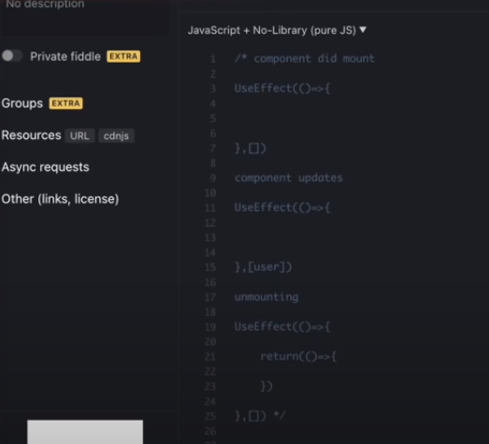

7)As above is output of bove question then How you will manage this state into functional component?

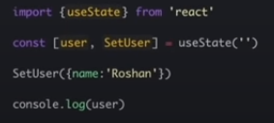

8)In above program tell me Is it applicable for only that component?How I can manage this or multiple component or inner component?

9)How can I prop drilling?

10)other than reduction any other method for this?

11)what is difference between reduction and contast topia?

12)what is significance of connect(map),map dispatch?is it class based?In function wht we have to do?

13)what is use of use reducer and use selector?

14)Where you cn use fetch activity call fetch and all?which stge you will call API?

15)Where we can call API?

16)For development what you will use?javascript or typescript?why?

17)Any use case with typescript action?any example?

18)Do you familiar with server side rendering in react?

19)what you feel diference between next react and your react?

20)what is strategy to style react component?any libraries?bootstrap libraries?

21)In material UI what is makestyle function will do?

22)Can we use multiple classnme in material UI?e.g grid.

23)What is testing strategy?Ho w unit testing works?

24)I have requirement in my project of language chnge?what will be your approach to use multiple language ?which libraries you will use?

25)Are you familiar with CMS?

26)How will you get data from wordpress?

27)Use fetch method to get printed only name from given link

28)If rom given data If I want to display the names of people who is having age more than 24?

29)Tell me about your previous project?How you managed it?(git branch n all)

30)Do you have any questions for me?